CHANGE REQUEST

EVALUATION RESPONSE

Change Request No./Name: | 021 - 80% Rule Disable
Requestor Name: | Ray Bassett
Review Date: | January 27, 2004
This Change Request has been | ___ | accepted without change
 | ____ | accepted with modifications
 | ____ | rejected

- Change Request:

The current 80% rule of functionality became irrelevant once the rating of the Bond structure was modified to accommodate the combination bonds. Aviva requested the removal of the current 80% rule of functionality and the modifications of the adjustments page in the Bond rating section of the requisition to accommodate this rule.

- Schedule:

The target completion date for this functionality will be January 31, 2004.

- Additional Resources Requirements:

Resource | Task | Xenex Effort in Hrs | Task | Surety Effort in Hrs
Business Analyst | Analysis and specifications | 1 | Detailed requirements, | 1
JSP developer | Modify the page labels as shown below | 4 |  | 0
Java developer | Disabling of the 80% rule code | 4
Tester | Unit, integration and regression testing | 1 | Acceptance criteria testing | 1
Sys. Administrator | Implementation | 1 |  | 0
Project manager | Manage the effort | 2 |  | 0
TOTAL EFFORT |  | 13 |  | 2

- Cost (detailed):
13 hrs x $100.00 = $1,300.00

- Total Cost:
$1,300.00 CDN

- Party Responsible For Cost:
Aviva

- Cost Payment Due Date:
- 50% upon the completion of the Regression Testing
- The balance upon completion of Acceptance Criteria Testing

- Acceptance Criteria / Deliverables:
- Label changes to the pages as described in the attachment of the email below
- Disabled current 80% rule functionality
- The ability to calculate the 80% rule through the modified adjustments page.

- Request documentation:

  - Request email:

From: Raymond_Bassett@avivacanada.com
Sent: Tuesday, January 27, 2004 1:18 PM
To: Lorice Haig
Cc: Laurie_Denham@avivacanada.com
Subject: Change Request 21 - "80% Rule" Disable
Further to our discussion yesterday, please provide a quotation and impact for the following change.
- on Client > Accreditation > Facility Terms > Rate tab:
  - disable and hide the check box and text for the 80% rule. This code must no longer affect rating on a requisition.
  - change the labels for the columns as per attached screen print
    - on Requisition > Recommendation > Rating > Adjustments (for all bond types) - the row labelled ""Broker Incentive Discount" change row label to read "80% Rule Discount" per attached screen print.
Lorice, because the current 80% rule coding does seem to affect the premium calculation, this change is now critical. Please advise soonest so we can provide our approval.
Thanks, Ray.
Raymond Bassett
National Manager, Surety Risk Management
Aviva Insurance Company of Canada
5140 Yonge Street, 18th Floor
North York, Ontario M2N 6L7
Phone: 416-228-2490
Fax: 416-229-5429
* * * * * * * * * *
This e-mail and attachments are intended only for the named recipient(s). If you are not the named recipient, please telephone or e-mail the sender immediately and delete this e-mail. You should not disclose the content or take, retain or distribute any copies of this e-mail or any attachments.
* * * * * * * * * *

  - Request email Attachement:

Change Labels on Client > Accreditation > Facility Terms > Rates tab as follows:

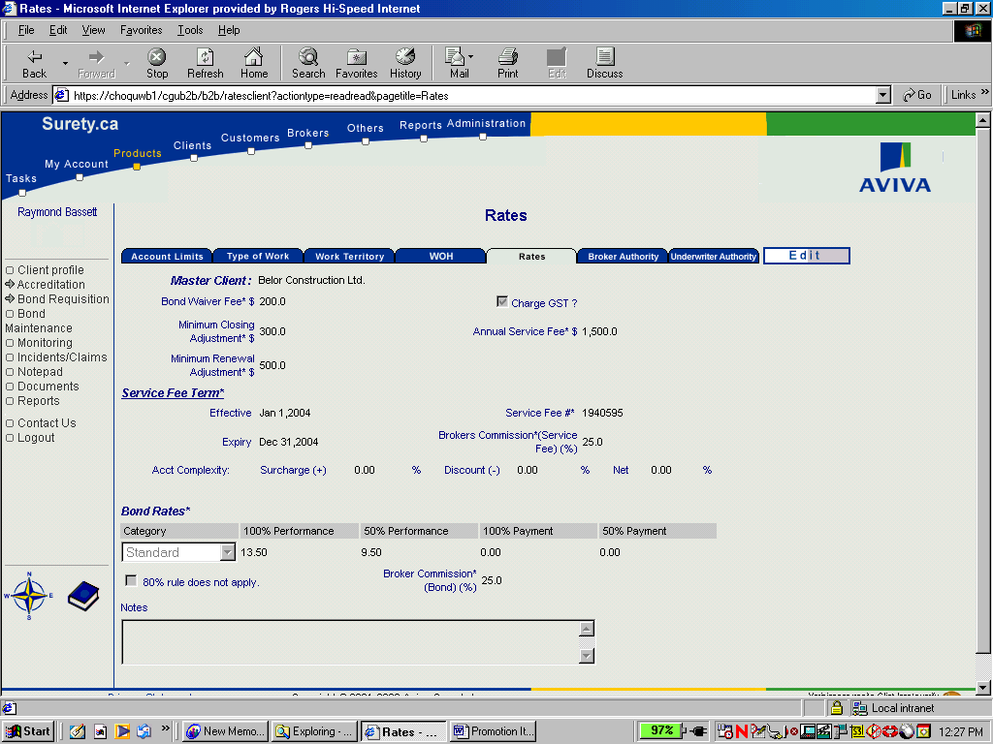
disable and hide the check box and text for the 80% rule. This code must no longer affect rating on a requisition.
Change this label to read:

“100/100 Combined Rate”
Change this label to read:

50/50 Combined Rate
Change these labels to be blank.
(Text Only)

Change row label on Requisition > Recommendation > Rating > Adjustments as follows:

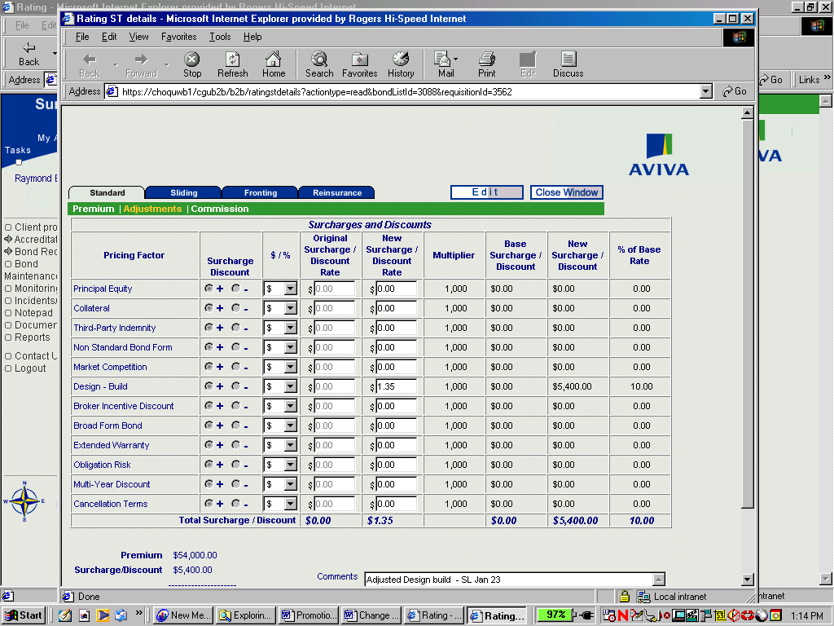
Change this label to read:
“80% Rule Discount from Combined Rate”

AGREED AND SIGNED:
Requestor Responder
Signature: Signature:
Name: Name:
Title: Title:
Date: Date:

